Sample Information Sheet

Sample ID: #C2054,0,35,17,0
Please note that this particle when returned, in accordance with the curator, was renamed as #C2054,0,35,17,0. In fact, A. Rotundi noticed, during a Stardust Workshop, that results on #C2054,0,35,16,n (so as thin section) where presented, while the grain was in her hands as bulk grain.
Sample type: whole extracted particle

Type of analysis performed: micro-IR spectroscopy in transmission mode, micro Raman spectroscopy, FESEM/EDS, optical microscope.
State of sample pre-analysis: Bulk grain unaltered.
State of sample post-analysis: unaltered.
Minerals or other phases identified:
- a. elemental composition (for species at >0.5wt%):
C = 7.00 wt%; O = 40.64 wt%; Na = 2.35 wt%; Al = 4.13 wt%;
Si = 9.41 wt%; K = 18.26 wt%; Ca = 1.52 wt%; Fe = 1.27 wt%;
Br = 8.50 wt%.
b. isotopic composition
c. size 13.5 micron
d. mineral associations

Contaminant phases identified : Aerogel was present on this grain in a low amount with respect to the amount present on the other grains analyzed with the same analytical techniques by our team.

Additional Notes: (paste sample image and /or EDS spectrum in JPEG format here if available)
The optical image aspect of sample #C2054,0,35,17,0 shows a yellowish and light grain.
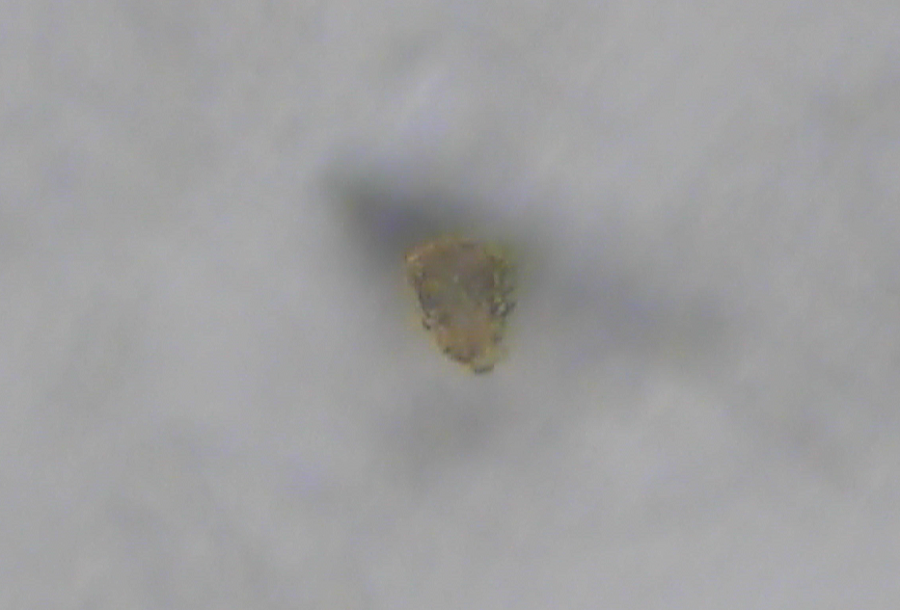

The surface of sample #C2054,0,35,17,0 is porous recalling the porosity of the aerogel impacted by a high velocity circumterrestrial particle (Comet99 experiment on-board the MIR station). Within the porous material are present some tiny grains possibly crystalline as indicated in the FESEM image (white arrows) and in the zoomed area. The big crystal underneath the grain is actually a KBr crystal part of the substrate: see the strait tracks present on the substrate continuing on the crystal (black arrow).

Element | Weight% | Atomic%
C K | 7.00 | 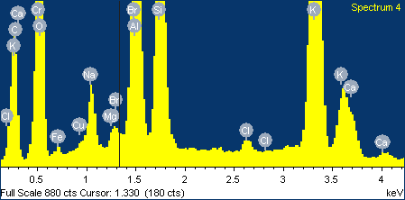  13.30
O K | 40.64 | 57.96
Na K | 2.35 | 2.33
Mg K | 0.30 | 0.28
Al K | 4.13 | 3.50
Si K | 9.41 | 7.65
Cl K | 0.40 | 0.26
K K | 18.26 | 10.66
Ca K | 1.52 | 0.86
Cr K | 0.22 | 0.09
Fe K | 1.27 | 0.52
Cu K | 0.46 | 0.17
Br L | 8.50 | 2.43
Totals | 94.46 | 100.0
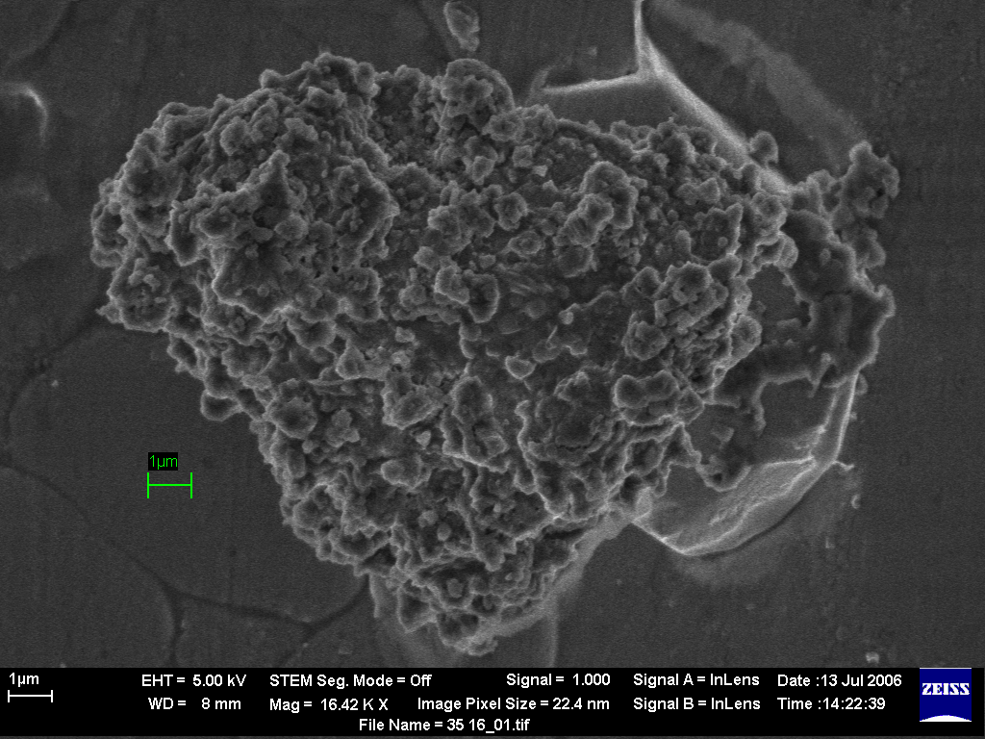
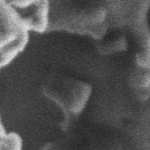
13.5 μm
13.5 μm

Spectrum of particle #C2054,0,35,17,0 in the 4000-1350 cm⁻¹ region with indication of band positions.

#C2054,0,35,17,0 optical image acquired with the Raman microscope. The signed sample positions correspond to the Raman spectra on the right.


